EXPORT JOURNAL ENRTY IN CSV/XLS

STEP 1:

GO to accounting-> journal entires-> use advance filters:
1.1 “comapny” “contains” “ur company name”
1.2 “journal” “contains” “ur jounrnal name”
NOTE : copy jorunal name by open journal entry-> click on journal-> now copy journal name

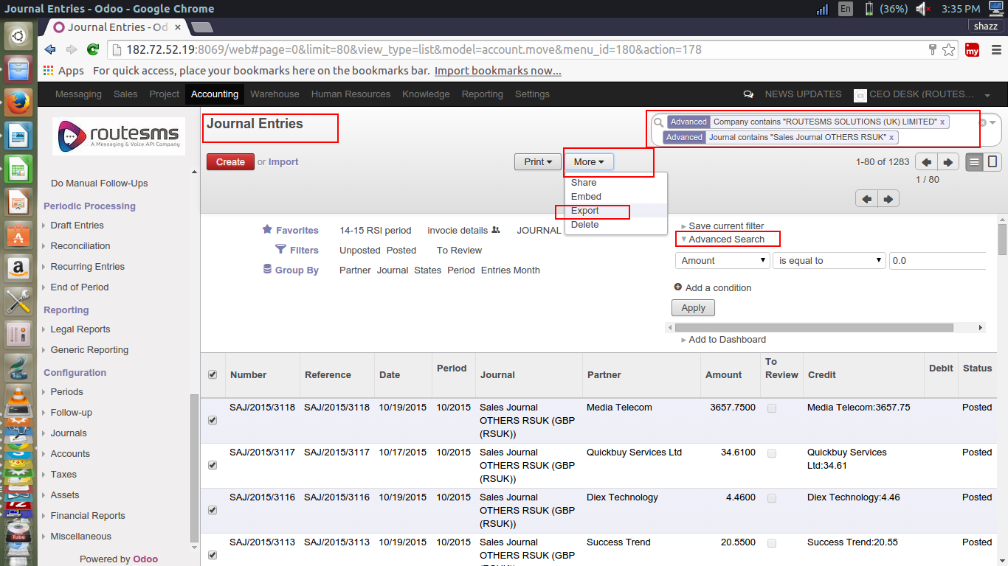

STEP 2:

Select template name from list and hit export button

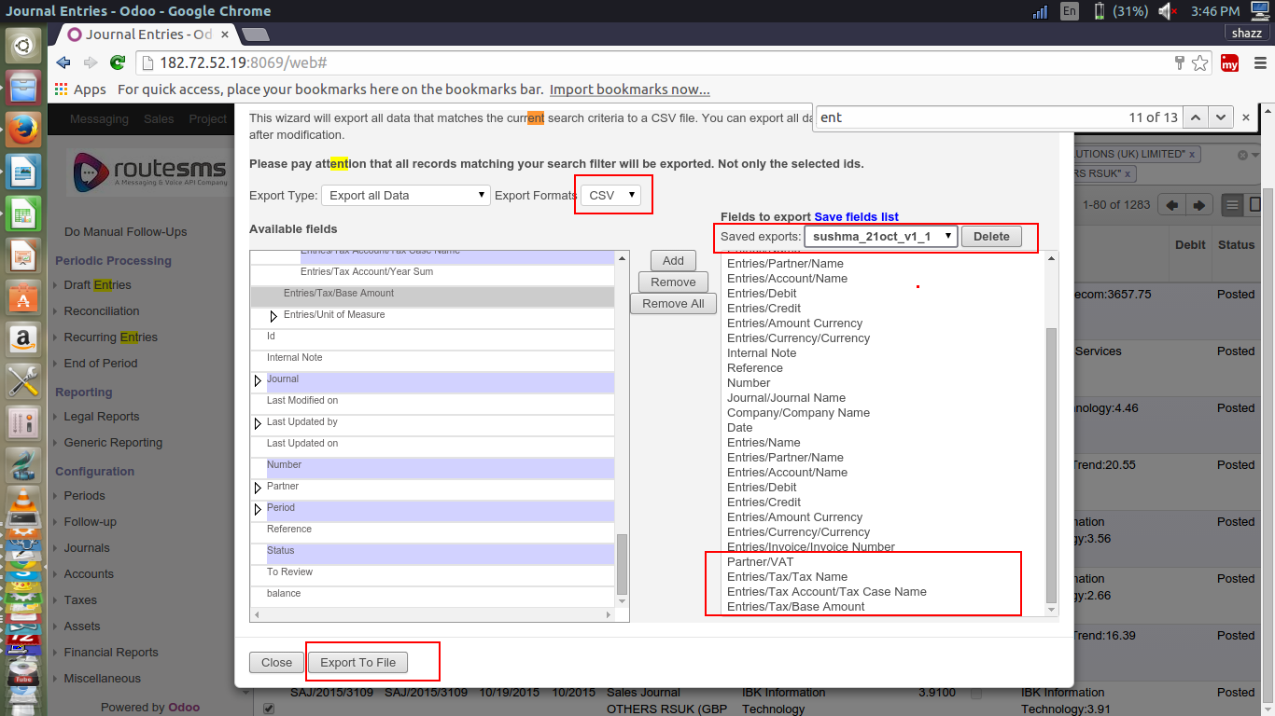

STEP 3:

Download and view sheet

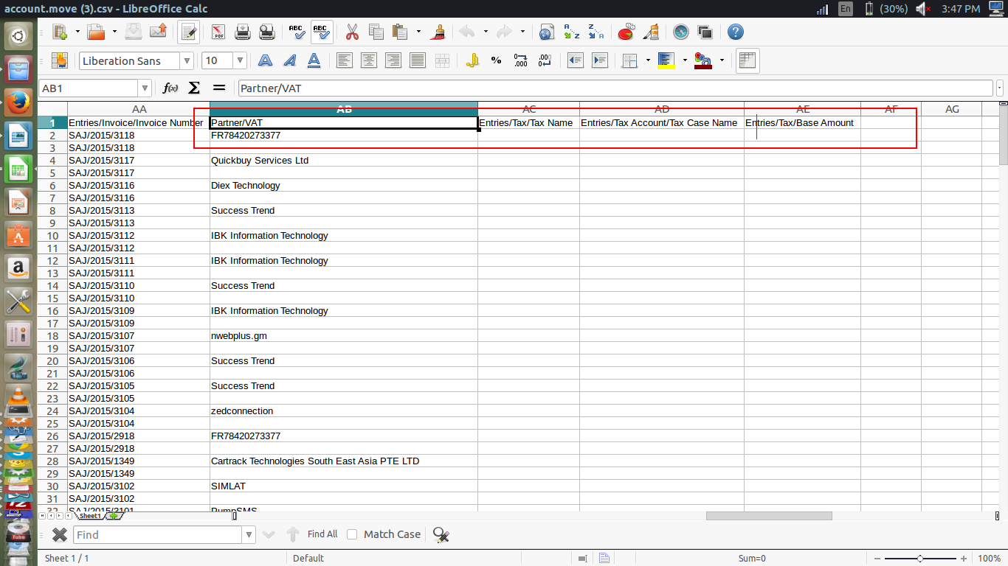

THANK YOU

